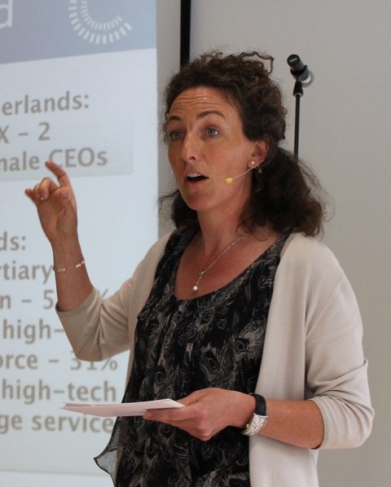

Caroline Pickard
Caroline Pickard has been teaching English since 2004. Originally from the UK, Caroline moved to the Netherlands as a graduate trainee for a major British logistics company. Caroline decided to settle in the Netherlands in her twenties and moved via recruitment and project management into customer service management. Caroline switched to teaching when she became a parent and learnt the ropes as a freelancer working for language schools. In 2009 she set up her own company and now works both directly with clients and via institutes, specialising in business English but also giving customised classroom, academic and general English courses. At the same time, she continues to be involved in the corporate environment, working part of the week as a consultant for a global research organisation.



Ian Badger
Ian Badger is a partner in Business and Medical English Services (www.bmes.co.uk). He is based in Bristol, but travels widely as a communications consultant, trainer and conference speaker. He is the author of Collins English for Business: Listening which was shortlisted for a 2012 British Council ELTON award. The iPad app based on this material won the 2012 David Riley award for innovation in Business English and ESP. He is also author of Collins English for Life: Listening B1+ and Listening B2+, co-author of English for Business Life and author of Everyday Business English and Everyday Business Writing.

Understanding business English however it is spoken
In this interactive session, we will discuss the value of using authentic recordings specifically to prepare our students for the listening challenges they meet in the business world. How do we help learners to understand language which is spoken with an unfamiliar accent, is grammatically ‘incorrect’ and does not conform to patterns of usage studied in the standard school or university classroom? I will demonstrate key differences in using authentic recordings compared with scripted ones in terms of accents, ‘mistakes’, fragmented sentences, etc. We will analyse examples of non-scripted materials and discuss how we can create our own to meet the specific needs of our learners. We will also consider ways in which non-native and native speakers should make efforts to make themselves clearer and more intelligible to their international counterparts.

